Monthly Performance Report – August 2026
Kestrel Ridge Wind Farm (75.6 MW)
David Chen · 09 September 2026 · KR-OPS-RPT-2026-08

1. Summary
Kestrel Ridge generated 13.0 GWh in August 2026, 3.2 % above the P50 budget of 12.6 GWh. Time-based availability was strong at 97.8 % (contract target 97.0 %). Mean hub-height wind speed was 7.2 m/s, above the long-term monthly mean of 6.9 m/s. Compared with August 2025 (12.3 GWh), output was up 0.7 GWh.
Drone blade inspection campaign completed on all 54 blades. Leading edge erosion progressed on 4 blades from Category 2 to 3; rope-access repairs are planned for May–June 2027.

2. Production and key figures
KPI | August 2026 | Budget / target | YTD 2026 | YTD budget
Net generation (GWh) | 13.0 | 12.6 | 129.6 | 133.6
Time-based availability | 97.8 % | 97.0 % | 97.0 % | 97.0 %
Capacity factor | 23.1 % | 22.4 % | 29.4 % | –
Mean wind speed at hub height (m/s) | 7.2 | 6.9 | – | –
Source: Kestrel Ridge SCADA, revenue meter at 132 kV point of connection. Budget = P50 (2024 post-construction yield assessment).
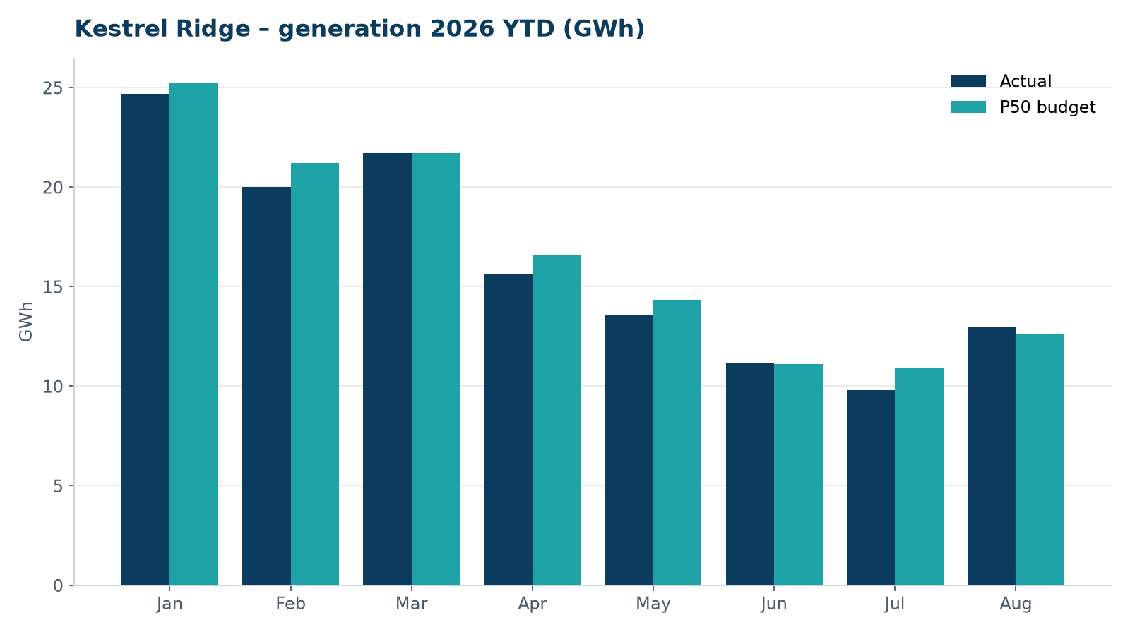
Monthly generation vs. P50 budget, 2026 year to date

3. Availability and downtime
Total turbine downtime attributable to the contractor amounted to 23 turbine-hours for the top events listed below. No grid or force majeure exclusions were claimed this month.
Turbine | Event | Downtime (h)
T-12 | anemometer heater failure – sensor replaced | 8
T-15 | generator slip ring brush wear alarm | 8
T-02 | service lift fault – lift locked out, turbine stopped for rescue cover | 7
Top downtime events of the month (SCADA event log, reviewed with Highline Wind Services).

4. Maintenance
- Annual service: 2 turbines completed this month.
- 14 corrective work orders closed, 4 still open at month end.
- Site access track inspected; two drainage culverts cleared after heavy rain.

5. Health, safety and environment
Indicator | Month
Hours worked on site (Highline + Weyland) | 4,035
Lost time injuries | 0
First aid cases | 0
Near misses reported | 0
Safety observations | 11
Environmental incidents | 0

No complaints from neighbours were received this month.

6. Outlook
Next month's focus: closing open corrective work orders and preparing the quarterly O&M review with Highline Wind Services.
Prepared by Sara Lindgren (Performance Analyst); reviewed by Ben Okoye (Site Manager) and David Chen (Asset Operations Manager).

